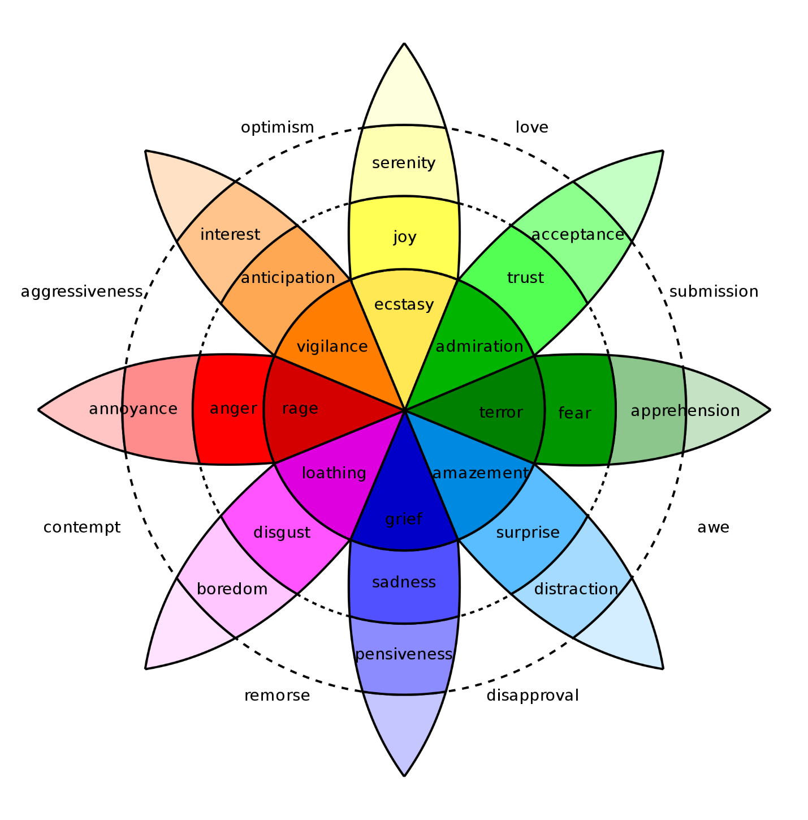

Fig: Plutchik-Wheel

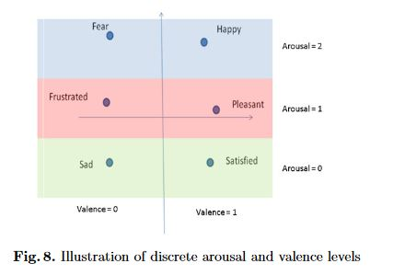

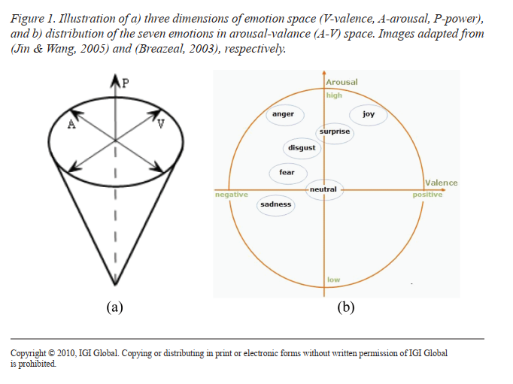

Fig: automatic, dimensionaland Continuous EmotionrecognitionHatice Gunes, Imperial College London, UKMaja Pantic, Imperial College London, UK and University of Twente, EEMCS, TheNetherlands

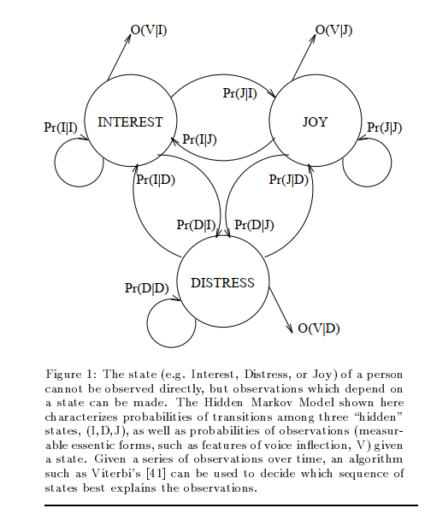

Affective Computing, R W Picard

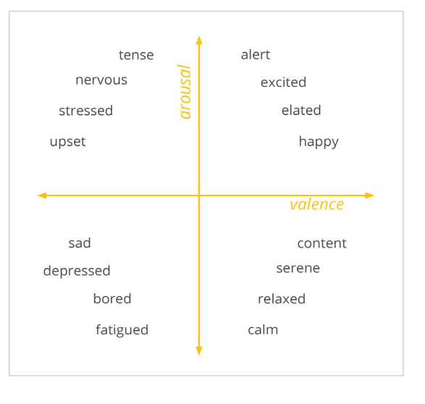

Fig: iMotions (white paper)